Name : Saraansh Mishra

Enrolment No. : A12405218064

Class : 5CSE13X

Q. Write a python program to create a tuple

Code with output:-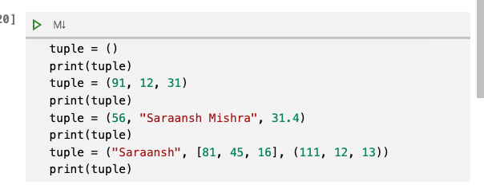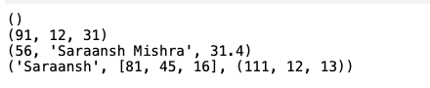

Q. Write a python program to create a tuple with different data types

Code with output:-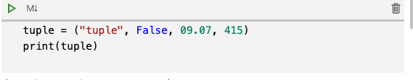



Q. Write a python program to create a tuple with numbers and print one item.

Code with output:-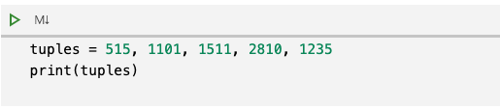



Q. Write a python program to add an item in a tuple.

Code with output:-